**Abstract**

Recommender Systems have become an essential part of various online applications by providing higher customer satisfaction through personalised recommendations. Most of the research in this domain focuses on improving the recommendation methods for higher accuracy values but the inconsistencies or the noise is often ignored. There exist mainly two types of noise in recommender systems: malicious and non-malicious or natural noise. The main reason behind natural noise existence is faulty user behaviour i.e. careless/erroneous preference selection. Malicious noise arises when deliberate attempts are made to tamper the output results in some manner. We believe that both classes of noise are important and can adversely affect recommendations. Therefore, we propose to simultaneously handle both malicious and natural noises.

For the detection of natural noise, we characterize users and items based on their ratings into different classes and identify a rating as noise if it contravenes user or item tendencies. We correct these identified naturally noisy ratings by prediction using collaborative filtering approaches. For the malicious noise, we use a value-based neighbour selection which selects neighbours for active users in user-based collaborative filtering recommender systems under shilling attack. We provide an empirical evaluation of our approach for validation.

**Contents**

1. **Introduction ………………………………………………………………………. 07**
2. **Literature Review ………………………………………………………………… 08**
   1. Collaborative Filtering Recommender Systems (CFRS) ……………………... 08
      1. User-based Collaborative Filtering ……………………………………. 08
      2. Item-based Collaborative Filtering ……………………………………. 09
   2. Natural Noise in Recommender Systems ……………………………………. 09
   3. Malicious Noise in Recommender Systems …………………………...……. 10
   4. Research Gap …………………………………………………………...…… 10
3. **Handling Natural Noise in CFRS ……………………………………….………. 11**
   1. Noisy Rating Detection ………………………………………………………. 11
   2. Noise Correction ……………………………………………………………... 12
4. **Validation Testbed ..…………………………………………………………….... 13**
   1. Dataset ………………………………………………………………………... 13
   2. Prediction and Evaluation Metrics …………………………………………… 13
5. **Results ………………………………………………………………………….… 14**
6. **Conclusion and Future Prospect (Handling Shilling Attacks in CFRS) ……... 16**
7. **References ………………………………………………………………………... 17**

**1. Introduction**

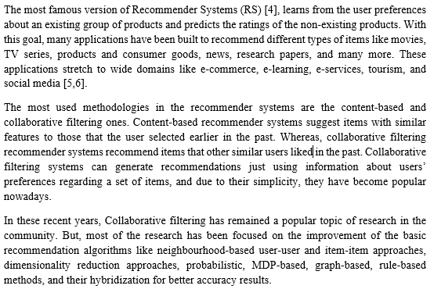Today, Recommender Systems have become a significant part of most of the commercial websites such as Amazon, Flipkart, Netflix, IMDB and LinkedIn. These websites are incorporating recommender systems in their mainframe systems to provide personalized user experiences in order to serve them better and increase overall sales and revenue. They recommend items or products that might be interesting for a user. As the amount of data being generated is increasing with every second, the scope for recommender systems is also widening to guide users through this massive amount of data. The problem or rather confusion due to the availability of hundreds of options for products to perform a task is increasing and recommender systems can prove to be very useful in solving that.

It is often assumed that in the RS, ratings provided by the users which act as the main source of information for the recommendation algorithms are free of irregularities unlike the classical data mining processes where we spend a significant amount of time in data pre-processing to clean the data. Recently Amatriain et al. [7,9] explained in his paper how the users could be inconsistent while giving the ratings or may illicitly provide false ratings, exposing the recommender systems data to inconsistencies. We address these inconsistencies as noise in recommender system databases.

Mahony et al. [8] in their paper titled ‘Detecting Noise in Recommender System Databases’ have classified these noises into two categories: Natural (Non-Malicious) and Malicious noise. They state that the main reason behind the natural noise is the imperfect user behaviour (e.g. erroneous/careless preference selection) and the different rating collection processes that are being employed. Whereas the malicious noise is injected deliberately by malicious users who seek improper benefits through recommendations. They either promote their own products to active users or demote competitors’ products. These users are known as the shilling attackers and their activities are known as shilling attacks [10].

In the research done so far on the consideration of noise in recommender systems, most of the works fall in either of the above mentioned two categories but no one to the best of our knowledge has tried to consider both malicious and natural noise simultaneously. In this contribution, we have tried to detect and correct both the types of noises and later compare the results with the classical recommender systems without the noise rectification to check the correctness of the hypothesis. We have used Movielens dataset to perform the analysis.

**2. Literature Review**

With a large number of developments in the field of Recommender Systems and their improvement, millions of consumers are getting motivated to go for online shopping and movie streaming, etc at a lower searching costs. The user review data is also increasing with every second. However, many of the recommender systems face problems of noisy ratings by users. Sometimes these noisy ratings are naturally induced by the misbehaviour of the user who is providing the rating while, sometimes malicious users intentionally hamper with the ratings in order to promote their own product or demote others’.

In this section, we have given an overview of the collaborative filtering approach and recent works related to the handling of noise are discussed. First, we discuss about the natural noise and then about the malicious attacks. Later, we discuss the research gap and how our approach can be effective in dealing with noise in recommender systems.

* 1. **Collaborative Filtering Recommender Systems:**

Collaborative filtering recommender systems ( CFRS ) suggest items to the users based on previous preferences of items rated by all the users. CF is a technique to recommend items based on similarity values. There are two types of collaborative filtering methods [12]:

* + 1. 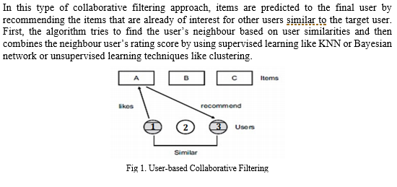**User-based CF (memory-based):**

* + 1. 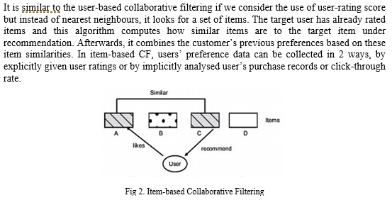**Item-based CF (model-based):**

In our study, we have used these two classical approaches of CF for evaluation and analysis.

* 1. **Natural Noise in Recommender Systems**

Natural noise refers to the inconsistencies that are incorporated into the user-item rating matrix unintentionally by the users. Sometimes, users give faulty ratings because of lack of interest or bad mood, etc. This leads to inconsistencies in the rating matrix which affects the performance of the recommender system.

Amatriain et al. [7,9] explains how consideration of natural noise and its correction is important for recommender systems and it leads to the improvement in accuracy of the recommendation algorithm. O’ Mahony et al. [8] in his paper uses comparison of user predicted preference for an item with rating of that item. He uses a set of genuine user profiles manually obtained for predicting these ratings and removes the ratings whose difference exceeds some threshold. However, this method always removes the highly deviating ratings which can be outliers also.

Li [15] suggested a method of detecting natural noise by assuming that the ratings given by a user on nearly correlated items should have similar scores. He identified users that had a high noise degree and removed these users from the dataset, increasing the accuracy of CFRS. This approach is limited to user level only and better approaches are needed that consider noise on all levels.

Toledo et al. [1] detects inconsistencies in the recommender system by characterizing users, items and ratings by their profiles into separate classes and then looking for contradictions among those profiles. He followed a re-prediction method using correlation coefficient (Pearson’s) for correcting the faulty ratings. Yera et al. [14] employed a fuzzy approach together with re-prediction method for handling natural noise. Researchers have also used re-prediction, local and global noise management, fuzzy profiling approaches in recommender systems.

Choudhary et al. [13] used a similar approach as of Toledo et al [1] for detection and correction of noisy ratings and generated recommendations using dice similarity coefficient between the active users along with optimized weights using particle swarm optimization (PSO). This method has limitations when the dataset is sparse and the optimal choice of PSO parameters is difficult.

In most of the re-prediction approaches the evaluation has been done on less sparse datasets. But, in sparse dataset, the correlation coefficient (Pearson’s) and neighbourhood search method for prediction doesn’t always give correct results. Therefore, instead of re-prediction, we follow a re-classification approach for users, items and ratings and then look for contradictions between those classes to detect noisy ratings.

* 1. **Malicious Noise in Recommender Systems**

Most of the CFRS rely on the opinions of the users for the items or the rating given by them and are vulnerable to the shilling attacks which can be manipulated to increase/decrease the sale of a target item by recommending it more/less. These shilling attacks are becoming a great threat to the recommender systems as they not only influence the performance of the recommender system but also, reduces the trust of the customer in the recommendation platform by misleading them.

There are many types of solutions to tackle shilling attacks for the CFRS and the most famous is by the detection of fake user profile. In this, we detect the malicious user by noticing the features of attack types. But, most of the models are limited to particular attack types only and majority of the methods detected anomaly user rather than intentional attacker. We propose to follow the detection of anomaly item directly as followed by Xia et al [21], which in turn is similar to detecting items attacked by fake users. The approach is based on the assumption that the item’s intrinsic quality follows a uniform distribution and the rating distribution of items remain stable in absence of shilling attacks. In this way, this approach is independent of the attack types.

There are mainly two types of shilling attacks considering the attack intention: push attacks and nuke attacks [22]. Attacks whose objective is to increase the sales of the target items are called push attacks whereas the attacks whose objective is to decrease or reduce the sales of the target items are called nuke attacks.

* 1. **Research Gap**

Most of the research has either been done on either natural noise handling or malicious noise attacks but in our research, we try to consider and remove both the types of noise and then compare the results. We propose to use a re-classification approach instead of a re-prediction approach as recommended by Toledo et al [1]. For malicious attacks, we think to implement a dynamic time interval segmentation technique to detect the anomaly against shilling attacks by looking for abnormalities in item profiles. The same approach was followed by Xia et al [21].

To the best of our knowledge, no one has tried to remove both these types of noise in CFRS using individually focused methods for each type of noise. However, this report only contains the results and analysis for natural noise handling only, the shilling attack part is still to be implemented and evaluated on Movie Lens Dataset.

1. **Handling Natural Noise in CFRS**

We use the user-item rating values to detect and correct natural noise in recommender systems, in this way no additional information about users and items is needed. Users give noisy ratings either unintentionally (bad mood or lack of interest, etc) or intentionally (special cases) but these ratings may change his user profile and can generate recommendations which are not suitable for him.

Our approach for dealing with natural noise contains two steps:

1. Noisy ratings detection: Classification of user and item profiles into 4 different classes based on the ratings. Ratings themselves are classified as weak, average or strong and then we look for intra-class contradictions.
2. Noise Correction: The identified noisy ratings are corrected with the thresholds of the inter-class boundaries. Bag et al. [11] suggest following this instead of re-prediction.
   1. **Noisy Ratings Detection:**

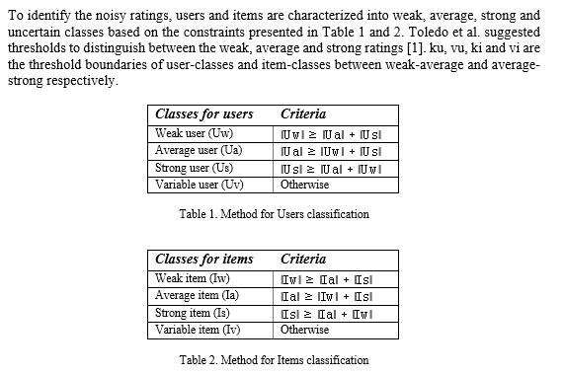

So, first the user-ratings are classified into weak, average or strong based on these threshold boundaries and then the cardinalities of each classes for users and items are compared to classify them as described in the above tables. The complete algorithms can be seen as follows:

**Algorithm 1: Classification of User’s classes Algorithm 2: Classification of Item’s classes**

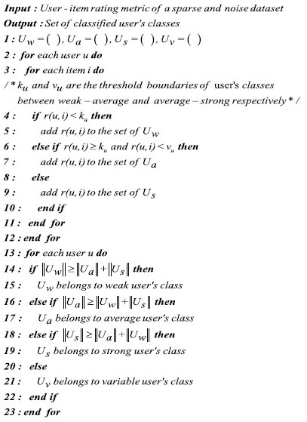 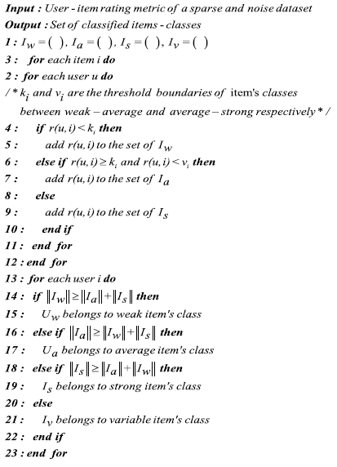

Now, the next step is correction of these identified natural noise.

* 1. **Noise Correction:**

For the correction of natural noise, we look for the contradictions among the user, item and rating classes. If both the user and item classes are weak but the rating is strong, then replace the noisy rating with the threshold of weak-average class. If both user and item belong to average classes and the rating is either weak or strong then it is replaced with the mean of thresholds for weak-average and average-strong classes. At last, if both the user and item belong to strong classes and the rating is weak then it is replaced with the threshold of average-strong class.

In this way, the noise correction is done and after that, the unknown ratings are predicted using user-user collaborative filtering and item-item collaborative filtering approaches using cosine similarities. The further analysis and evaluation are explained in the next section.

**Algorithm 3: Noisy rating correction**

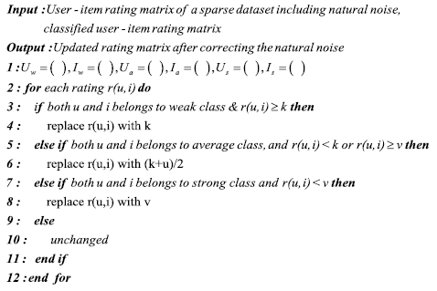

1. **Validation Testbed**

In the following sub-sections, the validation testbed for the experimental analysis is explained which includes the details of dataset and evaluation parameters.

* 1. 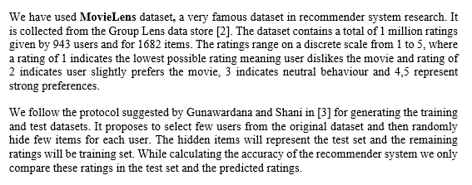**Dataset**
  2. **Prediction and Evaluation Metrics**

We have used User based collaborative filtering and Item-based collaborative filtering for prediction and cosine similarity for generating the similarity between users and items. The algorithms’ quality is calculated using Mean Squared Error (MSE) for all the predictions made in the test set.

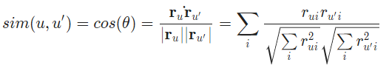

Fig 3. Cosine similarity formula

For user-based collaborative filtering, we predict that a user’s u’s rating for item i is given by the weighted sum of all other users’ ratings for item i where the weighting is the cosine similarity between each user and the input user u.

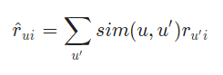

We must also normalize by the number of ru’i ratings:

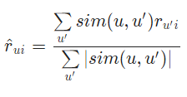

Fig 4. Rating Prediction formula

For item-based collaborative filtering, instead of user-user similarity values we use item-item similarities. We can attempt to improve our prediction MSE by only considering the top k users who are most similar to the input user (or, similarly, the top k items). We try to find the optimum value of k by trying out different values and then analysing the test errors.

1. **Results**

|  |  |  |  |  |
| --- | --- | --- | --- | --- |
| **k** | **Noise Corrected User-based CF train MSE** | **Simple User-based CF train MSE** | **Noise Corrected User-based CF test MSE** | **Simple User-based CF test MSE** |
| **5** | 1.821979 | 1.875663 | 8.469821 | 8.952164 |
| **10** | 2.638975 | 2.691344 | 7.404366 | 7.721665 |
| **15** | 3.05267 | 3.121662 | 7.013152 | 7.271317 |
| **20** | 3.322753 | 3.396814 | 6.783077 | 7.023413 |
| **25** | 3.52128 | 3.609356 | 6.641782 | 6.883827 |
| **30** | 3.687529 | 3.779436 | 6.565137 | 6.800327 |
| **35** | 3.830741 | 3.922667 | 6.519378 | 6.74686 |
| **40** | 3.955262 | 4.052634 | 6.49333 | 6.718763 |
| **45** | 4.064607 | 4.166282 | 6.485966 | 6.696686 |
| **50** | 4.163331 | 4.26887 | 6.48514 | 6.681174 |
| **55** | 4.252474 | 4.36372 | 6.476548 | 6.67671 |
| **60** | 4.333391 | 4.450926 | 6.474075 | 6.67367 |
| **65** | 4.408836 | 4.531853 | 6.478096 | 6.678984 |
| **70** | 4.481774 | 4.608197 | 6.485592 | 6.686241 |
| **75** | 4.547994 | 4.680004 | 6.491986 | 6.694332 |
| **80** | 4.614255 | 4.747234 | 6.500494 | 6.70396 |
| **85** | 4.674508 | 4.810772 | 6.510176 | 6.710295 |
| **90** | 4.732572 | 4.872641 | 6.518374 | 6.717036 |
| **95** | 4.790864 | 4.932101 | 6.529863 | 6.73387 |
| **100** | 4.843891 | 4.988904 | 6.538085 | 6.745619 |

Table 3. User-based Collaborative Filtering Mean Squared Errors for Noise Corrected and Normal scenarios on training and test datasets for different k (top-k) values

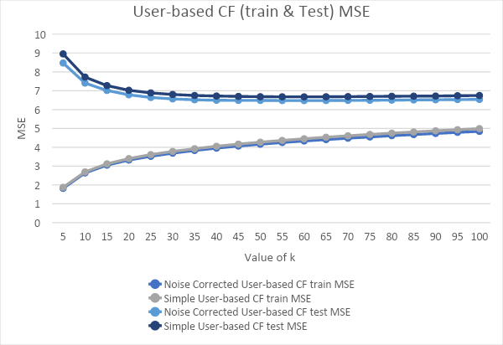

Fig 5. User-based CF Training and Test Errors for different k values

|  |  |  |  |  |
| --- | --- | --- | --- | --- |
| **k** | **Noise Corrected Item-based CF train MSE** | **Simple Item-based CF train MSE** | **Noise Corrected Item-based CF test MSE** | **Simple Item-based CF test MSE** |
| **5** | 1.613517 | 1.691159 | 8.26332 | 8.745066 |
| **10** | 2.290939 | 2.365884 | 7.570153 | 7.930925 |
| **15** | 2.652164 | 2.749226 | 7.436371 | 7.796198 |
| **20** | 2.900794 | 2.99845 | 7.437813 | 7.774712 |
| **25** | 3.095299 | 3.183482 | 7.473872 | 7.812725 |
| **30** | 3.253437 | 3.348762 | 7.525974 | 7.893234 |
| **35** | 3.393325 | 3.488442 | 7.608783 | 7.96932 |
| **40** | 3.51117 | 3.605437 | 7.67508 | 8.052454 |
| **45** | 3.614892 | 3.712047 | 7.743558 | 8.131801 |
| **50** | 3.712686 | 3.81038 | 7.814856 | 8.209364 |
| **55** | 3.804354 | 3.901119 | 7.888687 | 8.280585 |
| **60** | 3.888919 | 3.985525 | 7.961512 | 8.354438 |
| **65** | 3.967432 | 4.070067 | 8.031378 | 8.430379 |
| **70** | 4.0418 | 4.146834 | 8.092228 | 8.495702 |
| **75** | 4.112744 | 4.220293 | 8.159288 | 8.558617 |
| **80** | 4.179169 | 4.290909 | 8.215012 | 8.623238 |
| **85** | 4.244049 | 4.358464 | 8.273361 | 8.685048 |
| **90** | 4.307907 | 4.427405 | 8.330321 | 8.747409 |
| **95** | 4.369562 | 4.492336 | 8.384995 | 8.806533 |
| **100** | 4.430462 | 4.555911 | 8.439378 | 8.864087 |

Table 4. Item-based Collaborative Filtering Mean Squared Errors for Noise Corrected and Normal scenarios on training and test datasets for different k (Top-k) values

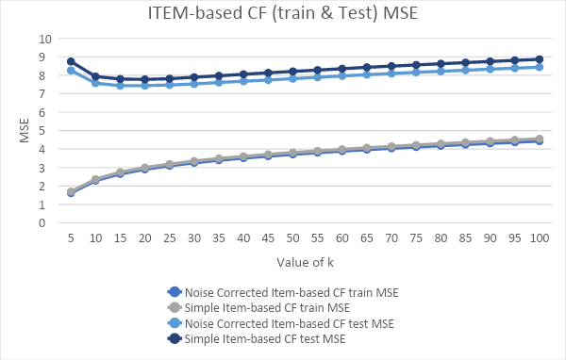

Fig 6. Item-based CF Training and Test Errors for different k values

1. **Conclusion and Future Prospect (Handling Shilling Attacks in CFRS)**

Till now, in this research, we explained the re-classification based approach for Natural Noise detection and correction. We used User-User and Item-Item based collaborative filtering approaches for making predictions for the unknown rating values using the modified and corrected user-item rating matrix which is free from any natural noise.

In the future, we plan to apply the malicious noise handling approaches as followed by Xia et al [21] and Cai et al [22]. We plan to follow a dynamic time interval segmentation technique based item anomaly detection to tackle the problem of shilling attacks. Using this approach can make the process independent of the attack type and looks for abnormalities in item profiles. After handling the shilling attacks, we will have a robust recommender model free of both natural and malicious noise and we expect to increase the accuracy in this way. In the end, we can also perform a detailed accuracy analysis using multiple datasets in order to validate the results thoroughly.

1. **References**

[1] R.Y. Toledo, Y.C. Mota, L. Martínez, Correcting noisy ratings in collaborative recommender systems, Knowledge-Based Systems 76 (2015) 96–108, https://doi.org/10.1016/j.knosys.2014.12.011.

[2] GroupLens, MovieLens datasets, https://grouplens.org/datasets/movielens, (2017), Accessed date: 30 December 2018.

[3] A. Gunawardana, Shani, G., "A survey of accuracy evaluation metrics of recommendation tasks," Journal of Machine Learning Research, vol. 10, pp. 2935-2962, 2009.

[4] G. Adomavicius, Tuzhilin, A., "Toward the next generation of recommender systems: A survey of the state-of-the-art and possible extensions," IEEE Transactions on Knowledge and Data Engineering, vol. 17, pp. 734-749, 2005.

[5] K. J. B. Schafer, J.A., Riedl, J., "E-commerce recommendation applications," Data Mining and Knowledge Discovery, vol. 5, pp. 115-153, 2001.

[6] E. J. Castellano, Martínez, L. , "A Web-Decision Support System based on Collaborative Filtering for Academic Orientation. Case Study of the Spanish Secondary School.," Journal of Universal Computer Science, vol. 15, pp. 2786-2807, 2009.

[7] X. Amatriain, Pujol, J., Oliver, N. , "I like it... I like it not: Evaluating user ratings noise in recommender systems," presented at the 17th International Conference on User Modeling, Adaptation and Personalization (UMAP), 2009.

[8] M. P. O’Mahony, Hurley, N.J., Silvestre, G.C. , "Detecting noise in recommender system databases.," presented at the 11th ACM International Conference on Intelligent Users Interfaces (IUI) 2006.

[9] X. Amatriain, Pujol, J., Tintarev, N., Oliver, N., "Rate it again: Increasing recommendation accuracy by user re-rating.," presented at the 3rd ACM International Conference on Recommender Systems (RecSys), 2009.

[10] P.A. Chirita, W. Nejdl, C. Zamfir, Preventing shilling attacks in online recommender systems, Proceedings of the 7th Annual ACM International Workshop on Web Information and Data Management, NY, 2005.

[11] S. Bag, S. Kumar, A. Awasthi, M.K. Tiwari, A noise correction-based approach to support a recommender system in a highly sparse rating environment, Decision Support Systems 118 (2019).

[12] Lee, Yunkyoung, "RECOMMENDATION SYSTEM USING COLLABORATIVE FILTERING" (2015). Master's Projects. 439. DOI: https://doi.org/10.31979/etd.5c62-ve53

[13] Priyankar Choudhary,Vibhor Kant, Pragya Dwivedi, Handling Natural Noise in Multi Criteria Recommender System utilizing effective similarity measure and Particle Swarm Optimization, 7th International Conference on Advances in Computing & Communications, ICACC-2017, 22-24 August 2017, Cochin, India.

[14] Raciel Yera, Jorge Castro, Luis Martínez, A fuzzy model for managing natural noise in recommender systems, Applied Soft Computing 40 (2016).

[15] B. Li, Chen, L., Xingquan, Z., Chengqi, Z., "Noisy but non-malicious user detection in social recommender systems," World Wide Web, 2012.

[16] https://www.ethanrosenthal.com/2015/11/02/intro-to-collaborative-filtering/

[17] https://towardsdatascience.com/various-implementations-of-collaborative-filtering-100385c6dfe0

[18] http://files.grouplens.org/papers/FnT%20CF%20Recsys%20Survey.pdf

[19] https://towardsdatascience.com/collaborative-filtering-and-embeddings-part-1-63b00b9739ce

[20]https://medium.com/sfu-big-data/recommendation-systems-user-based-collaborative-filtering-using-n-nearest-neighbors-bf7361dc24e0

[21] Hui Xia, Bin Fang, Min Gao, Hui Ma, Yuanyan Tang, Jing Wen, A novel item anomaly detection approach against shilling attacks in collaborative recommendation systems using the dynamic time interval segmentation technique, Information Sciences 306 (2015).

[22] Yuanfeng Cai, Dan Zhu, Trustworthy and profit: A new value-based neighbor selection method in

recommender systems under shilling attacks, Decision Support Systems 124 (2019).